Start Developing for Android

Go to <http://developer.android.com/sdk/index.html>



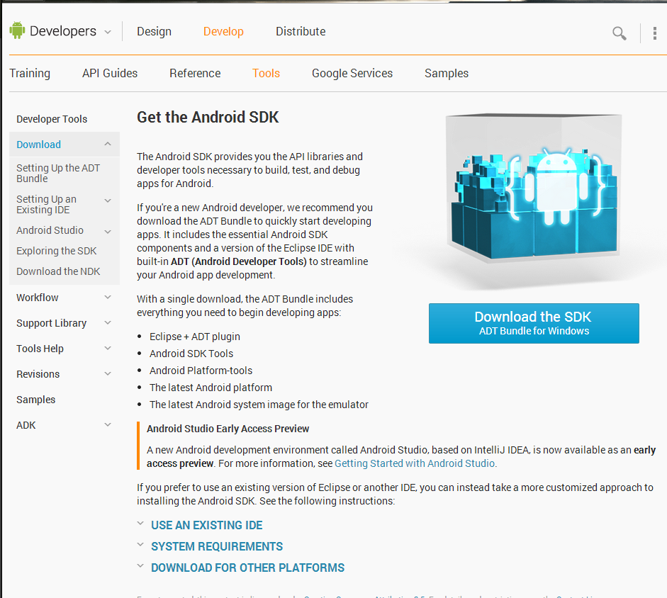

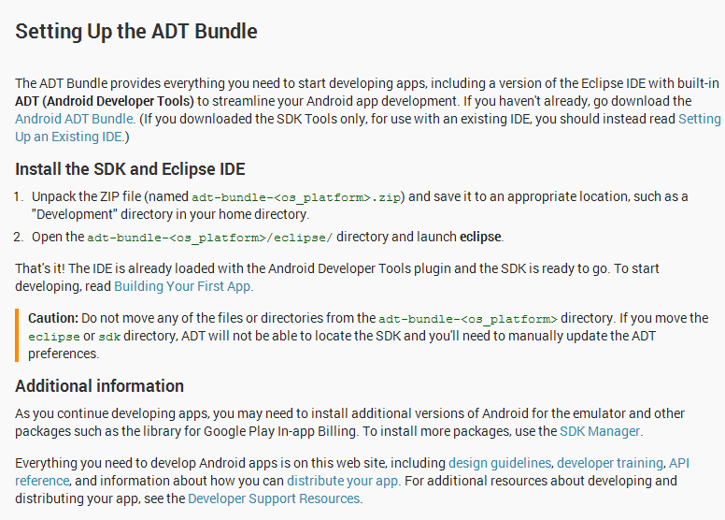

Setting up the ADB Path

Move your adt bundle to wherever you want it.

Go to file explorer (Win + e)

Right click This PC



Click “Properties”

Click “Advanced System Settings”

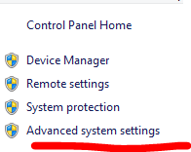

Click “Environment Variables”

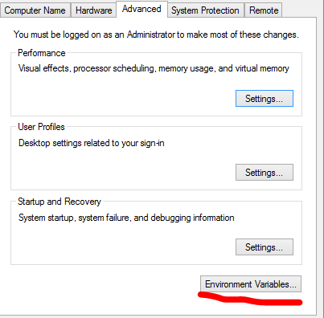

Click “Path” and then “Edit”.

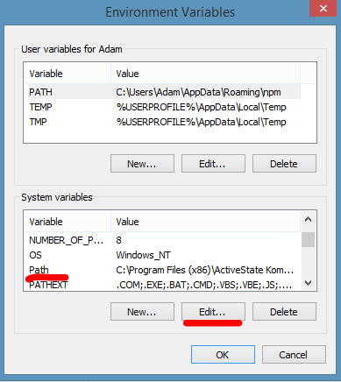

Go to wherever you put your adt bundle and copy the address.

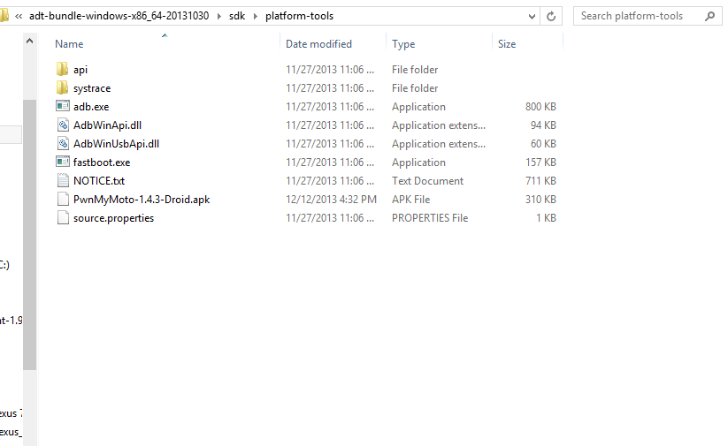

Add a Semicolon (;) to the end of whatever is there, and paste the address to wherever your adt bundle is located.

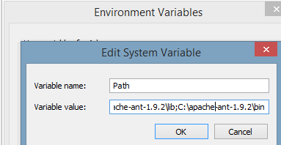

Press “OK”

Go to command prompt and type “adb” to make sure it’s working.

It should look like this.

